**Introduction:**

# CSE 421

Lab 2 :Observing DNS and ARP in Packet Tracer

# ID 23341124

Simulation mode in Packet Tracer captures all network traffic flowing through the entire network . You will observe the packets involved in DNS and ARP process. These two protocols are the helping protocols when a web page is requested using HTTP.

### Objectives:

1. Explore how PT uses the OSI Model and TCP/IP Protocols.
   * Creating a Simple PDU (test packet)
   * Switching from Realtime to Simulation Mode
2. Examine a Web Request Packet Processing and Contents
   * Accessing the PDU Information Window, OSI Model View
   * Investigating the layers and addresses in the OSI Model View
   * Animations of packet Flow

**Task 1: Observe the network topology shown.**

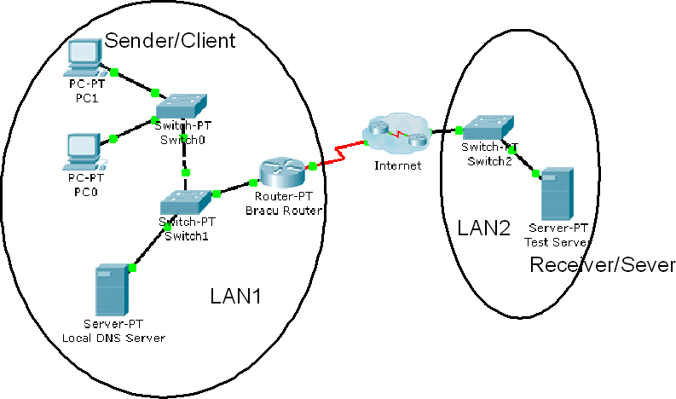

* **PC0**, **PC1** and the **Local DNS server**, **BRACU router** is part of a Local area network. BRACU router connects this LAN to the Internet through an ISP. The **Test server** shown is on another Local area network.
* You will access the web page [**www.test.com**](http://www.test.com/) which is stored in the Test Web Server through PC1’s web browser.
* To access this web page this activity will show you how and what packets are created and how the packets move through the network.
* For this activity we will only focus on DNS and ARP.

## Task 1: Capture a web request using a URL from a PC.

### Step 1 – Switching from Realtime to Simulation Mode

* + In the far lower right of the PT interface is the toggle between Realtime and Simulation mode. PT always starts in realtime mode, in which networking protocols operate with realistic timings.

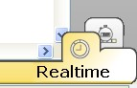

Simulation Tab

* + In simulation mode, you can visually see the flow of packets when you send data

from an application. A new window named “**Event List**” will appear. This window will show the packets (PDUs) as colored envelopes.

•

### Step 2 – Run the simulation and capture the traffic.

* + Click on the PC1. Click on the **Desktop tab**. Open the **Web Browser** from the **Desktop**.
  + Write [**www.test.com**](http://www.test.com/) into the browser. Clicking on **Go** will initiate a web server request.

**Minimize** the PC1 Client window.

* + Look at the Event List Window. Two packets appear in the **Event List**, a **DNS request** from **PC1** to the **Local DNS server** needed to resolve the URL [“ww](http://www.test.com/)w[.test.com”](http://www.test.com/) to the IP address of the Test server.
  + Before the DNS request can be sent, we need to know the DNS Server’s MAC address. So the 2nd PDU is the **ARP request** needed to resolve the IP address of the DNS server to its hardware MAC address.
  + Now click the **Auto Capture / Play** button in the Event List Window to run the simulation and capture events.
  + Sit tight and observe the packets flowing through the network.

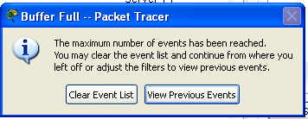

* + When the above message appears Click “View Previous Events".
  + Click on PC1. The web browser will now display a web page.
  + Minimize the PC1 window again.

### Step 3 – Examine the following captured traffic.

|  |  |  |  |
| --- | --- | --- | --- |
|  | **Last Device** | **At Device** | **Type** |
| 1. | PC1 | Switch 0 | ARP |
| 2. | Local DNS Server | Switch 1 | ARP |
| 3. | PC1 | Switch 0 | DNS |
| 4. | Local DNS Server | Switch 1 | DNS |
| 5. | -- | PC1 | HTTP |

* + Find the following packets given in the table above in the **Event List**, and click on the colored square in the **Info** column.

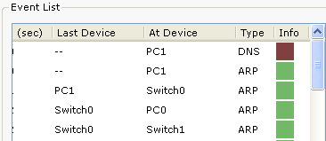

* + When you click on the Info square for a packet in the event list the **PDU information** window opens.

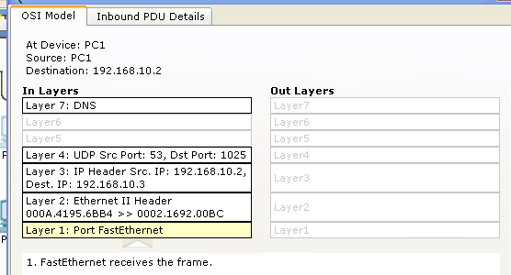

* + This windows displays the OSI layers and the information at each layer for each device. (At Device).
  + If you click on these layers, the algorithm used by the device (in this case, the PC) is displayed. View what is going on at each layer.
  + Examine the PDU information for the remaining events in the exchange.

#### Packets 1&2 representing ARP packets:

Packet 1 represents the ARP request by PC1. Which devices’ MAC addresses are included as source and destination?

PC1 is the source and Broadcast message is the destination

Why is PC1 sending an ARP packet?

It sends ARP so that it finds the correct mac address

Why was this packet sent to all devices?

PC1 has an Ip address but it do not know whose ip address is this. To know that and to know mac address it sent packet to all devices.

Packet 2 represents the ARP reply by the Local DNS server. What is the difference in the devices’ MAC addresses are included as source and destination?

local DNS server is the source and PC1 is the destination.

#### Packets 3&4 representing DNS packets:

Packet 3 represents the DNS request made by PC1, why? Which devices’ IP addresses are included as source and destination?

PC1 is source and DNS local server is the destination.

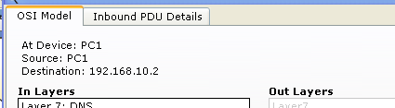

Click onto “Inbound PDU details” tab. Scroll down, you should come across “DNS Query”. What is the purpose of this DNS Query?

To determine the IP address of www.test.com

Packet 4 is the reply from the DNS server, what is the difference between Packet 1 and Packet 2 source and destination IP addresses?

Source is local DNS server and destination is PC1.

For packet 4, click onto “Inbound PDU details” tab. Scroll down, do you see anything different after the DNS query?

Length value has changed and IP address is different.

#### Packets 5 is the HTTP request for the web page made by PC1.

Details of this packet will be observed later.